TOPICS COVERED
What is BAS (Business Application Studio)
SAP Business Application Studio (BAS) is a web-based development environment (IDE Like VS CODE) provided by SAP for building applications on the SAP Business Technology Platform (BTP), especially in the Cloud Foundry environment (run time Environment for Application).
It Provides Pre-Configured Environment (No need manual Installations for Node.js or CF-CLI) for several application Development like SAP Fiori Development/CAP Development.
How to work in BAS

1.Open BAS & Create Dev Space

Steps:
- Go to SAP BTP → Open BAS
- Click Create Dev Space
- Choose type:
  - Full Stack Cloud Application (for CAP + Node.js) ✅
  - Fiori (for UI apps)
- Start the Dev Space
Dev Space = your working environment

2. Understand BAS Interface
It looks similar to VS Code:
- Explorer → Project files
- Editor → Write code
- Terminal → Run commands
- Extensions → Add features

3. Create a Project (CAP Example)
Use Integrated terminal:
cds init myProject(Creates a new CAP project and Generates basic folders and files)
cd myProject(Moves into the project folder)
cds add hana(Adds SAP HANA database support(depenedencies/configuration) to your project)
cds add mta(Adds Multi-Target Application (MTA) configuration)

4. Project Structure
Typical CAP project:
myProject/
├── app/ → UI (Fiori)
├── db/ → Database models
├── srv/ → Services (OData)
├── package.json

5. Run Your Application
cds watch
This will:
- Start server
- Auto-reload changes
Open browser:
http://localhost:4004

6. Work with Code

Example: Service file
using { my.bookshop as my } from '../db/schema';
service CatalogService {
entity Books as projection on my.Books;
}
Define APIs here

7. Git Integration
In terminal:
git init
git add .
git commit -m "Initial commit"
git push

8. Install Dependencies
npm install
BAS supports:
Node.js

9. Debugging
- Use terminal logs
- Check errors in BAS console
- Use breakpoints (like VS Code)

10. Deploy to SAP BTP
mbt build
cf deploy mta_archives/*.mtar
Project Structure of BAS
After running cds init, your project looks like this:
myProject/
├── app/
├── db/
├── srv/
├── node_modules/
├── package.json
├── mta.yaml
└── README.md

2. Folder-by-Folder Explanation

app/ → Frontend (UI Layer)
- Contains UI apps (usually SAP Fiori)
- Built using HTML, JS, XML
Often uses:SAP Fiori

Example:
app/
└── webapp/
├── index.html
├── manifest.json

db/ → Database Layer
- Defines data models using CDS

Example:
db/
└── schema.cds
entity Books {
key ID : Integer;
title : String;
}
Purpose: Define tables & relationships

srv/ → Service Layer (Backend Logic)
- Exposes data as APIs (OData services)

Example:
srv/
└── service.cds
service CatalogService {
entity Books as projection on my.Books;
}
Purpose: Connect frontend with database

node_modules/
- Contains installed dependencies
Comes from: Node.js
Purpose: Libraries required for project

package.json
- Project configuration file

Contains:
- Dependencies
- Scripts
- Project info
{
"name": "myProject",
"dependencies": {
"@sap/cds": "^7"
}
}
Purpose: Manage project setup

mta.yaml
- Deployment configuration file
Related to: Multi-Target Application
Purpose: Deploy app to SAP BTP

README.md
- Documentation of project

3. Architecture Flow
UI (app/)
↓
Service (srv/)
↓
Database (db/)
Flow:
- User interacts with UI
- UI calls service
- Service fetches data from DB
Optional Files
- .cdsrc.json → CDS config
- .env → environment variables
- xs-security.json → security config

NODE.JS
Variable Declaration
variable determines its scope, hoisting behaviour , and whether or not it can be reassigned.
Const-Use it for values that shouldn't be reassigned, like imported modules or configuration settings.
Let- when you know a value will change, such as a counter in a loop or a variable that gets updated based on an if condition.
Var- Function-scoped (ignores block boundaries like if or for).

Why do we refer one file in another?
To:
- reuse code
- keep code clean and modular
- avoid writing everything in one file
module.exports makes the function available to other files
require('./math') → imports the file
CONCEPTS:
REUSE
Write code once and use it multiple times
REQUIRE
require() is used to:
Bring code from another file into your current file
LOOP
Repeat a task multiple times
Different Types Of Loop:-
For LOOP
Number of iterations is known.
Entry-controller Loop
for (let i = 1; i <= 5; i++) {
console.log(i);
}
While LOOP
Number of iterations is unknown.
Entry-controller Loop
let i = 1;

while (i <= 3) {
console.log(i);
i++;
}
Do-while LOOP
Number of iterations is unknown.
Exit -controller Loop
let i = 1;

do {
console.log(i);
i++;
} while (i <= 3);
IMPORTANT LOOP CONTROL STATEMENTS

break
Stops loop immediately
for (let i = 1; i <= 5; i++) {
if (i === 3) break;
console.log(i);
}

continue
Skips current iteration
for (let i = 1; i <= 5; i++) {
if (i === 3) continue;
console.log(i);
}
EVENT HANDLER
Event handler is a function that gets executed automatically when a specific event occurs. This is part of Node.js’s event-driven architecture, which is one of its most important concepts.
Node.js is event-driven, meaning:
Code runs when something happens (event)
const EventEmitter = require('events');
const emitter = new EventEmitter();

// Listener
emitter.on('greet', (name) => {
console.log("Hello", name);
});

// Trigger event
emitter.emit('greet', 'Jatin');
Part |  | Meaning
on() |  | listen for event
emit() |  | trigger event
'greet' |  | event name

Basic node.js Application using Key concepts such as Variable Declaration, Event Handling, Looping.
For these concepts we are building a basic Node.js Application
We create separate files to organize code (like a math module and a logger), then use require to reuse those functionalities in the main file. Inside the main program, we declare variables, perform operations using reusable functions, run loops to execute repeated tasks, and trigger events to understand Node.js event-driven nature.
We created 3 files other than package.json which is built automatically
Index.json
const math = require('./math');
const logMessage = require('./logger');

importing functions from other files.

let num1 = 5;
let num2 = 10;
Variable Declaration.

let sum = math.add(num1, num2);
let product = math.multiply(num1, num2);

calling functions from math.js (resuablke dunctions)
console.log("Loop Output:");
To print Loop Output

for (let i = 1; i <= 3; i++) {
console.log("Iteration:", i);
}
Defining a For Loop which will run 3 times and print Iteration 1…………..
// EVENT HANDLING
logMessage("Application started");
Calling function from logger.js
That function internally triggers an event

// OUTPUT
console.log("Sum:", sum);
console.log("Product:", product);
To print sum and product.

EVENT
Logger.js
const EventEmitter = require('events')
importing Node.js built-in events module
It gives you a class called EventEmitter
This class helps you:
- create events
- listen to events
- trigger events

const emitter = new EventEmitter();
Create an object of event manager class

// Event listener
emitter.on('log', (message) => {
console.log("LOG EVENT:", message);
});
When a log event happens, run this function
• 'log' → event name
• (message) => {...} → what to do when event happens

// Function to trigger event
function logMessage(msg) {
emitter.emit('log', msg);
}
This function is used to trigger the event

emit : Fire/trigger an event
module.exports = logMessage;
Makes this function usable in other files
• emitter.on('log') → “If someone announces ‘log’, do this”
• emitter.emit('log') → “I am announcing ‘log’ now”
Math.js
function add(a, b) {
return a + b;
}

function multiply(a, b) {
return a * b;
}

module.exports = {
add,
multiply
};
Creating two functions add and multiply and making it available for other files to access these functions.
Package.json
package.json is the main configuration file for your Node.js project.
• what your project is
• what dependencies it uses
• how to run it
Main attributes defined in Package.json

"main": "index.js"

Entry point of your application

"scripts": {
"start": "node index.js"
}
Now you just run:
npm start: Same result, but easier

same can be used for multiple scripts
"scripts": {
"start": "node index.js",
"dev": "nodemon index.js",
"test": "echo testing"
}
Run:
npm start
npm run dev
npm run test

USE SCRIPTS:
- avoid typing long commands
- standardize project commands
- make project easy for others

"version": "1.0.0"
Version of your app
Example:
- 1.0.0 → first stable version
- 1.0.1 → bug fix
- 1.1.0 → new feature
Creating First CAPM Application Using CDS
In BAS Select “NEW PROJECT FROM TEMPLATE”
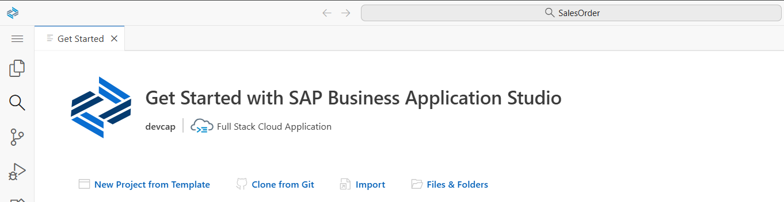
Select CAP Project and click on start
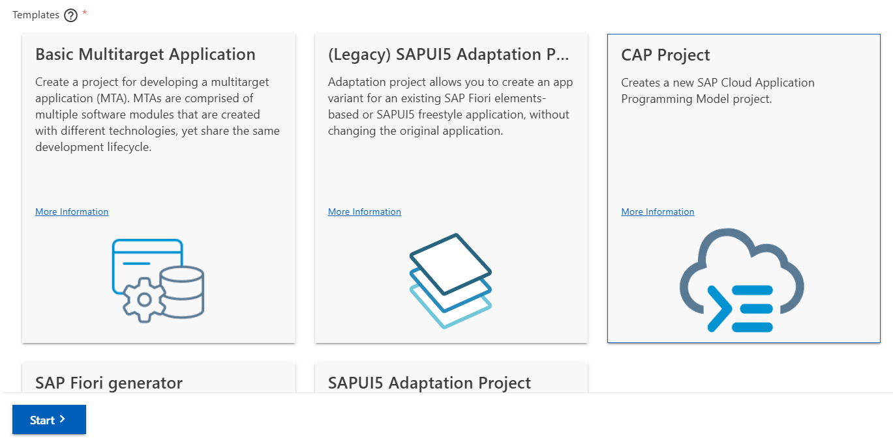
Enter Project name and click on Finish
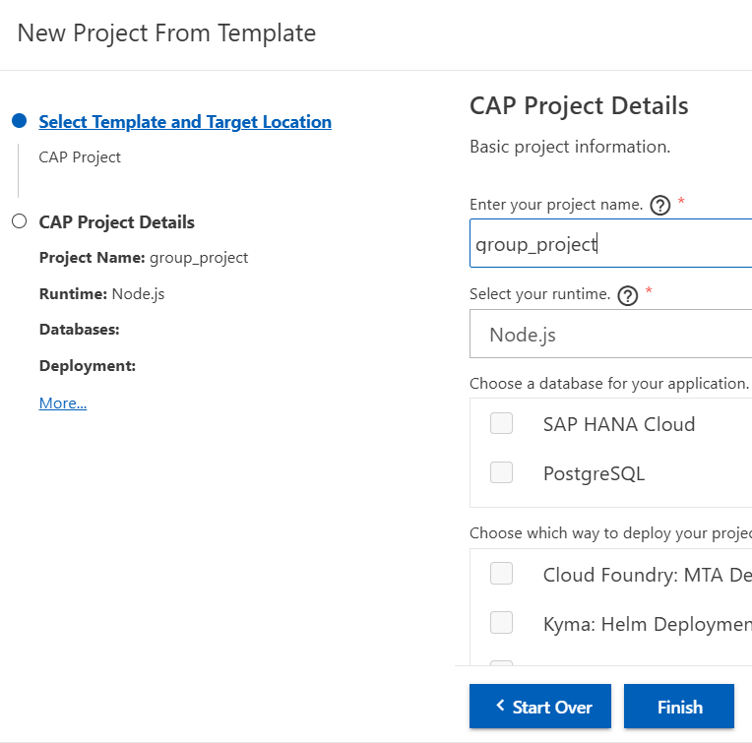
File Folder Structure for Project is automatically created.
Step 1.
The db folder is where you define your data model using CDS. CAP converts these definitions into real database tables during deployment.
Right Click on db folder & create a New File.
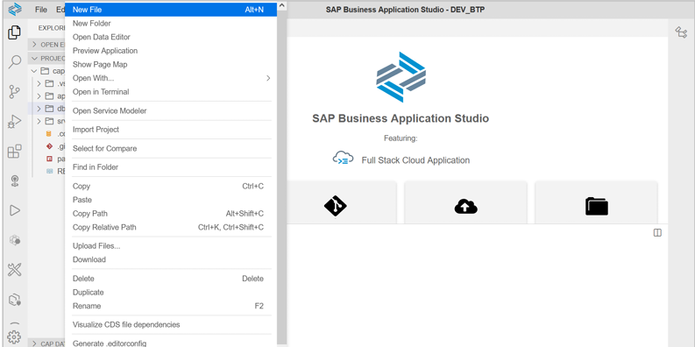
Name it as data-model.
Create Entities using given Command
namespace com.project.Salesorders;

entity SalesOrders {
@title : 'Sales Order Number'
key soNumber: String;
@title : 'Order Date'
orderDate: Date;
@title : 'Customer Name'
customerName: String;
@title : 'Customer Number'
customerNumber: String;
@title : 'PO Number'
PoNumber: String;
@title : 'Inquiry Number'
inquiryNumber: String;
@title : 'Total Sales Order'
totalOrderItems: Integer;
}
Explanation:

namespace com.project.Salesorders;
This is like a package name / folder structure
- Helps organize your models
- Makes your entity uniquely identifiable
entity SalesOrders
This defines a table
- SalesOrders = table name
- Each field inside = column
key soNumber: String;

This is the primary key
- key → uniquely identifies each record
- soNumber → column name
- String → data type
Rest are attributed for SalesOrder and giving each of them a title for Fiori Preview.
Step 2.
Navigate to the srv directory. Here, we will define the service layers that expose our underlying database entities as OData endpoints
Create a new file in srv folder by right-clicking on the same.
Enter name and paste the given code to create a service.
using { com.project.Salesorders.SalesOrders as DB_SalesOrders } from '../db/data-model';

service SalesOrderService {
entity SalesOrders as projection on DB_SalesOrders;
}
Explanation: It exposes your database entity as an API (OData service).

using { com.project.Salesorders.SalesOrders as DB_SalesOrders } from '../db/data-model';
• Imports the entity from your db layer
• Renames it to DB_SalesOrders

IMP: com.project.Salesorders.SalesOrders as DB_SalesOrders
We are re-naming it because of multiple reasons:
- Easier to use
- Avoids naming conflicts
- Prevents circular reference

service SalesOrderService : creates an OData service with API Endpoint like:
/odata/v4/sales-order

entity SalesOrders as projection on DB_SalesOrders
[Projection: exposing existing data ][ Exposes DB_SalesOrders as SalesOrders in the service.]
Expose the database entity DB_SalesOrders as SalesOrders in this service

NOTE:
- We can also Control Fields using custom Projection:
entity SalesOrders as projection on DB_SalesOrders {
soNumber,
customerName
};
- Entity orders as a projection on DB_SALESORDER
Whatever entity I define inside a service becomes an API endpoint. Here it’s /orders
• Package.Json name convention (can cause error)
lowercase only
can use - or _

Step 3. Create sample date to load in the service.
So, let's create a folder in db folder. Right-click on db folder and select New Folder.
Name your folder as data.
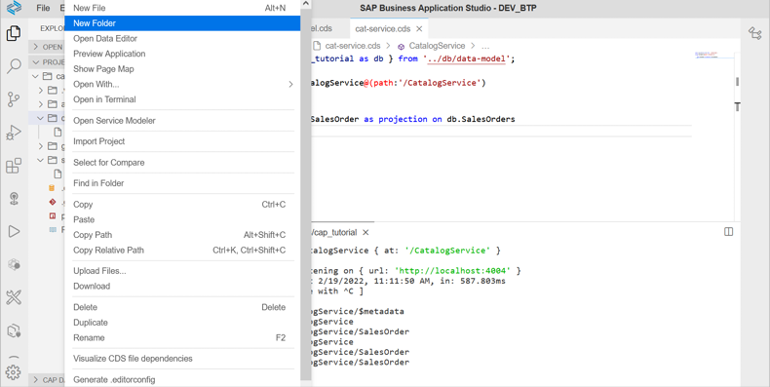
Now create a new file in the created data folder.
Name it as : <namespace name>’-‘<entity name>
This CSV file contains sample records that are automatically loaded into the SalesOrders table during deployment.
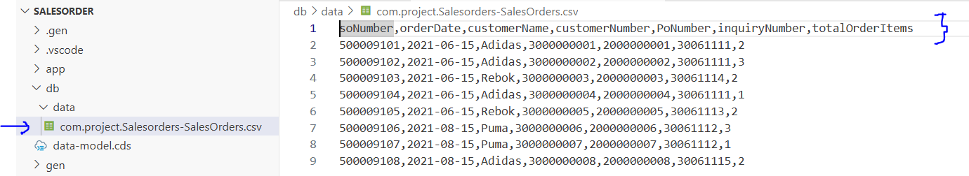
soNumber,orderDate,customerName,customerNumber,PoNumber,inquiryNumber,totalOrderItem
Header row (VERY IMPORTANT) Must match your CDS entity EXACTLY.
500009101,2021-06-15,Adidas,3000000001,2000000001,30061111,2
Each line = one record (row) in DB

Steps 4.
Lets cds build(Prepares your project for deployment) and cds watch(Runs your app locally + auto reload) for application to run locally.
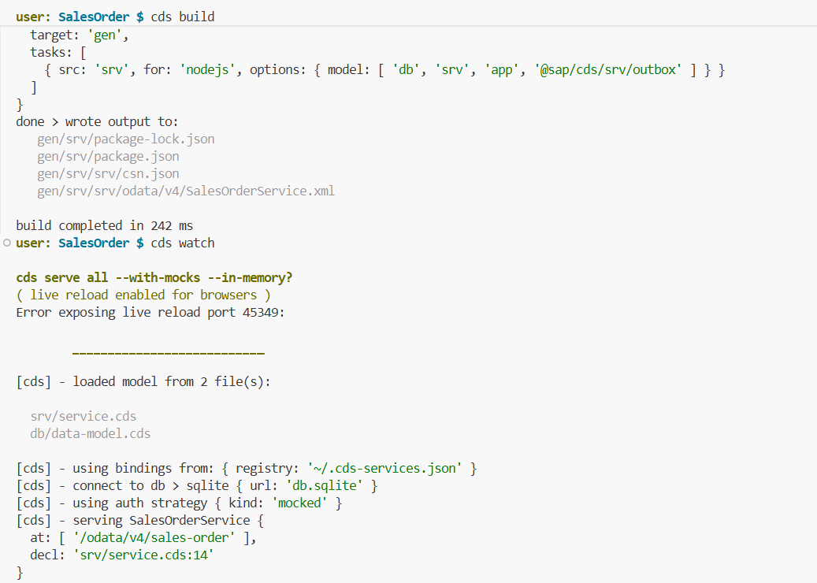
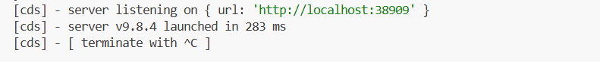
Use local host to run application.
